Homework 3 Solution

There are 8 problems, each for 12 points, except A –Exercises that are 14 points each.

Exercise R-4.4
There are several solutions. One is to draw the AVL tree created by the input sequence: 9,5,12,7,13 (note that no rebalances are needed). Now draw the tree created when you switch the 5 and the 7 in the input sequence: 9,7,12,5,13.

Exercise R-4.7
Wrong answer: Proof of Theorem 4.3 states that h<= 2log(n+1) +1, where n is the number of internal nodes and h is the height of the tree. Given h=8, 8<=2log(n+1) +1
Hence 7<=2log(n+1) which implies n+1>=2**3.5 =11.31, so n>=11. At least one internal node has a two external nodes, thus the number of nodes is more than 13.
But this does not say that we can built a red black tree of height 8 with 13 nodes. It takes a lot more nodes.

Wrong Answer: The smallest number of nodes that are possible in R-B Tree is 2**ℎ − 1, where ℎ is height of the tree assuming all nodes are black. Minimum number of nodes in R-B Tree of Height 8 is 𝟐**𝟖 − 𝟏 = 𝟐𝟓𝟓.
The best part of RB trees are coloring the trees, otherwise it is just another BST.

Correct answer: Build the Red Black tree of height 8 with the goal of having the minimum number of nodes:
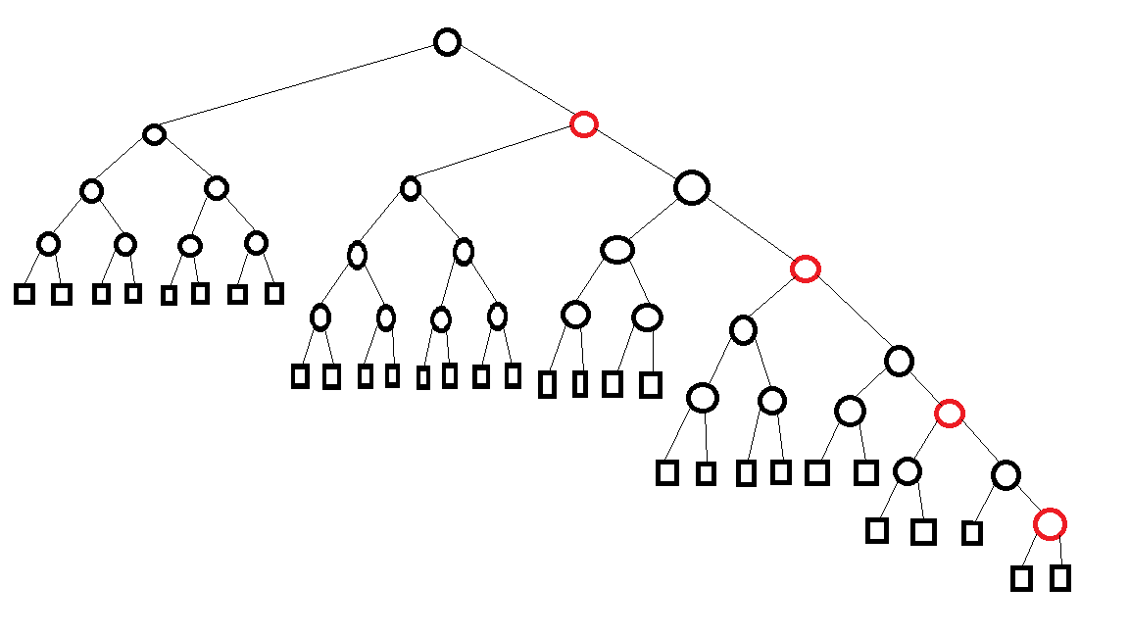

The above red-black tree does not violate any rule, has height and has nodes, including the leaf nodes.

The idea is to create a tree with the largest height and smallest number of nodes. This can be achieved by having the black depth of 8/2=4 for leaves and alternating black and red along the longest subtree.

Exercise C-4.15
The mergeable heap can be implemented using a binary tree. However, there are several common implementations of mergeable trees using Leftist Trees, Binomial Heap, or Fibonacci Heaps. You can find details in many Algorithms books such as “Introduction to Algorithms by Thomas Cormen, et al” and you find them on Internet including Wikipedia. The link below contains a solution using Leftist Trees.

http://www.dgp.toronto.edu/people/JamesStewart/378notes/10leftist/

Note that the operations insert(k,x), remove(k) take O(logn) min() takes O(1) all by nature of the heap. It is unionWith(h) that requires some kind of joining the heaps and restructuring it to maintain the Heap properties as described below:

Suppose heap k is being joined with h; i.e., unionWith(h). If h is NULL, then union returns k. If k is NULL, union returns h. This will be the trivial case for our recursion.

Suppose min(h) is smaller than min(k), then we use min(h) as the root of the union, with left subtree of h as its left subtree, and union the right subtree of h with k. If min(h) is larger than min(k), then we swap h and k and perform unionWith(k).

The new binary tree meets the heap requirements except possibly it may not be a complete binary tree. So at each stage of recursion, we check to see the

(height of the left subtree) – (height of the right subtree) <=1

If this is not true, we swap the left subtree and right subtree and continue.

Since unionWith(h) traverses along the height of the binary trees h and k, each with maximum of n nodes, it calls on each operation in unionWith(h) a few times of logn. Hence the running times of unionWith(h) is O(logn).

Exercise A-4.4
Store the elements from S in a balanced binary search tree, T, ordered by a combination of Zip code and name, where we ﬁrst go by Zip code and then break ties alphabetically. To do a search for a speciﬁc Zip code, k, we do a standard search for k and then list out all the nodes in subtrees that have k as their Zip code. The analysis is similar to that used for an in-order traversal, plus O(logn) for identifying the subtrees in T that need to be traversed.

Exercise R-5.6
A worst-case list for insertion sort would be one that is in descending order of keys, e.g., 44, 36, 29, 25, 22, 15, 13, 10, 9, 3. With this list, each element will ﬁrst be moved to the front and then moved back in the list incrementally, as every remaining is processed. Thus, each element will be moved n times. For n elements, this means at a total of n² times, which implies Ω(n²) time overall.

Exercise R-5.14
The first step is to replace the node 5 by node 18

Now we need to re- heap using a down heap operation.
We swap 18 for 9.

Now we again continue the down-heap operation.
Compare 18 to its children. We find that 12 is smaller than 18 so we swap 18 and 12 node.

Down heap reaches the external nodes. Operation complete.

Exercise C-5.9
Starting at the root of the tree, recursively search the left and right subtrees if the root of the subtree has a key value less than x. This algorithm takes O(k) time, because there is no node in T storing a key larger than x that has a descendant storing a key less than x.

Exercise A-5.3
Store upgrade requests in a priority queue, Q that is implemented with locator objects. In addition, store locators into Q for each upgrade request in an array, D. When a ﬂyer requests an upgrade, add his or her request to Q, and store the locator for this request in D, giving the ﬂyer the index, i, in D for this locator as the conﬁrmation number. If a ﬂyer requests a cancellation, using a conﬁrmation number, i, then look up their locator, D[i], and use it to remove their request from Q. To process k upgrades, perform k removeMin operations on Q. This allows all update operations to be performed in O(logn) time and for k upgrades to be processed in O(k logn) time.

